Different types of cameras

This article will talk about the different types of cameras in detail
But first let’s talk about what a camera is and why we need them in part 1:

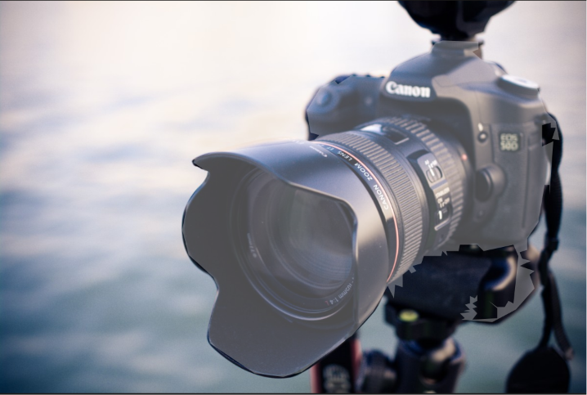
PART1:
How does a camera work ?:
The camera captures an image through the following steps :
Step1:
Light enters through the lens and the lens helps in focusing light onto the image sensor by refraction .
Step2:Lens focuses the light
- The lens bends ( refracts ) the light such that the rays converge and fall onto the camera sensor
- Proper focusing ensures that the camera image is sharp.
Step3:Aperture controls the light
- The aperture is an opening that controls how much light enters
- It is an adjustable opening where a larger aperture allows more light to enter while a smaller aperture reduces the amount of light
Step4:Shutter :
1)The shutter controls how long the camera lens is exposed to light
2) Longer exposure captures more light but increases motion blur
3) Shorter exposure decreases motion blur but the light may be captured in less amounts
Step5: Image sensor captures the light :
1)For this a sensor called a CMOS ( Complementary metal-oxide sensor ) or a CCD ( Charged couple device ) is used .
2) In this sensor , the light rays fall onto them and electrical signals are sent accordingly depending on the intensity of light.
3)Each pixel on the sensor measures the intensity of incoming light.
Step6 : Image processing :
The camera's image processor converts the electrical signals into a digital image.
Processing includes color correction, noise reduction, white balance adjustment, sharpening, and image compression.

Step7:Image storage
- The processed image is stored in the camera's memory card or internal storage in formats such as JPEG or RAW.

PART2:
Components of a camera :

- LENS: The main job of the lens is to focus all the light around the camera in one place.
It refracts all the scattered light around and entering the camera and focuses it into one place by converging them .
That way , a camera can form a clear and a crisp image.

3)Aperture :
The aperture is simply how large the opening of a camera’s lens is.
It controls:
i) How much a light enters
ii) The depth of field or how much of the scene appears in focus .

4) Shutter :
The shutter determines how long an image is exposed to
More the shutter speed ,shorter the exposure , darker the image and less the blur is.
But lesser the shutter speed , longer the exposure , brighter the image and more the blur is.

5) Image sensor :The heart of a digital camera
This is a tiny chip covered in millions of tiny elements called photosites .
These photosites emit electrical signals depending on the intensity of light
Later the signals are converted into digital numbers and these numbers become the pixels of your image
This is the moment when light becomes data
6) Image processing
Involves estimating full RGB values ( demiosacing )
Adjusting white balance
Reducing noise
Correcting lens distortion
Compressing the image

So the camera has one job:
Detect light and convert it into NUMBERS that a computer can access.

PART 3: Parameters of cameras :
1)Focal length : The distance between the camera lens and the image sensor when focused .Determines magnification and field of view

Effects :
Shorter focal length :greater field of view
Longer focal length :Narrower field of view , but with greater magnification

- The exposure triangle :

i)Apeture (F-number) :
Controls the size of the lens opening :

Effects :
Larger aperture : Smaller f - number such as f/1.8:
More light ,Brighter image ,Shallower depth of field
Smaller aperture : larger f-number such as f/1.6.
Less light,Darker image , Greater depth of field

How to read numbers like f/1.8 etc ?:

The F-number is calculated like this :
F-number=f/D ; Where f is the focal length and D is the diameter of the aperture opening
This number is more like a ratio : smaller the f- number indicates larger aperture( aperture diameter ) and more light coming in ,and larger the f-number indicates smaller aperture )
Two different lenses with same F-numbers can have different focal lengths and different apeture diameters

What is the depth of field ?:
The depth of field is just the amount of objects that’s visible

ii) Shutter speed :
The amount of time for which the shutter remains open
Eg , Faster the shutter speed , shorter that the camera lens is exposed ,
Lesser the motion blur and more dark the image is
Slow shutter speed means that the camera is exposed for longer
And brighter that the image can be ,but it introduces motion blur.

iii)ISO:
Represents the image sensitivity of the image sensor to the light
Iso .
How it works ? :
In ISO , We dont change how much light enters or anything , Instead ISO either leaves the electrical signal ( electrical signal emitted due to the photons of the light hitting the sensors ) or it amplifies the electrical signal to make it look artificially brighter.
Effect:
Low ISO :
Cleaner images
Less noise
High ISO :
Brighter images in low light
More noise
ISO Isn’t more brightness from more light , it’s more brightness from same captured light.

3)Focus :
Focus determines what part of the images appear sharp
Types :
i) Manual focus
ii) Autofocus

4)White balance :
Adjust images so that the white object appears white under different conditions

5 ) Resolution:
Resolution is the number of pixels in an image
Higher resolution :Captures finer details , Allows larger prints and greater cropping flexibility
6) Frame Rate : Frame rate is the number of frames captured per second
Higher frames rate produce smoother motion and enable slow motion playback .

PART4 : Types of cameras :

Let’s delve into types of cameras in detail
#1) RGB Cameras
1) What is a RGB camera ?:
The name “RGB “ Stands for “ red , green and blue “because this camera captures visible lighting using three different color channels , red , green and 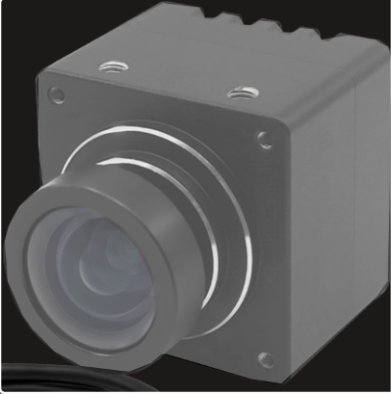
Blue.
It produces images similar to what the human eye sees, making it the most commonly used type of camera in everyday life.

We dont use all the color from red to pink to green etc because almost every color humans can perceive on a screen can be gotten by combining the three channels of red ,green and blue at different values.

Engineers chose RGB because it copies human biology specifically cone cells

2) what are the components of a rgb camera ?:

Several parts :
a)Scene : The subject that’s being photographed.
b)) Lens: The object that focuses all the light in one place, I mean the sensor
c)Apeture: This controls how much light enters the camera sensor.Acts as the camera’s pupil
d)Shutter:Controls how long the sensor collects light
Long exposure-> brighter image ->more motion blur
e)CMOS sensor: Heart of the camera and it’s covered with millions of tiny elements called the photosites .Each photosite measures the amount of light that falls during exposure

f)Image processor: The processor converts the sensor’s measurements into an image ( RGB ) That can be stored or displayed
Processes raw sensor data by:
1) Demosaicing
2) White balancing
3) Noise reduction
4) Color correction
5) Sharpening
6) Compression
g)Bayer filter : RGB sensors have a bayer filter ( Color filter array or CFA)
Each pixel records only one color :
i) red
ii) green
iii) blue
The missing colors are estimated using demiosacing .
h) Analog to digital converter (ADC):
Converts analog voltages from the sensor into digital pixel values .

- How does this camera work ?:
The working process is:
- Light enters through the lens.
- Aperture controls light quantity.
- Shutter controls exposure time.
- Light reaches the Bayer filter.
- Each pixel measures only one color (R, G, or B).
- Sensor converts light into electrical signals.
- ADC digitizes these signals.
- ISP reconstructs the missing colors using demosaicing.
- Final RGB image is produced
4) What Information does a rgb camera capture ?:
An RGB Camera captures :
i) Color and Each pixel stores red , green and blue intensities
ii)Brightness or overall light intensity
iii)Texture : Surface patterns and details
iv)shape: Object outline and boundaries
v) appearance : material color and visual characteristics
vi) 2-d coordinates of the pixel

An RGB camera cannot measure 3-D distance , 3-d coordinates, surface orientation and
Object size in real - world units

5)What are it’s Applications :
Smartphones , webcams , drones ,dslr and mirror less cameras ,drones cctv,robots

6 ) What are it’s Advantages?:
produces realistic color images that people can recognize , small and inexpensive lightweight ,supported by almost every computer vision library like openCV

7) What are it’s Limitations ? :
They don’t directly measure distance (depth) to objects
They need sufficient visible light to produce good images
Fast motion can cause motion blur.
Smoke , fog and heavy rain can reduce image quality
They can’t measure temperature directly.

9) What are it’s applications and why?:
i) Autonomous driving : Roads, signs, and traffic lights are color-dependent.
ii)Robotics : Helps robots recognize objects and environments
iii)Smartphones : Humans naturally prefer color photographs
iv)Survelliance : Easier Identification of clothing , people and vehicles
v) Industrial inspection :Detects color defects and markings

#2)Monochrome Cameras :

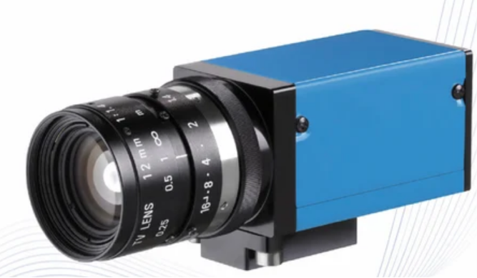

- What is it ?:
A monochrome camera captures images only in grayscale ( black-and-white )
Each pixel stores one value representing how bright or dark one part of the scene is .
Instead of recording red ,green or blue values , it records only brightness or darkness of that particular scene.

Example :
Brightness value | Appearance
0 | Black
64 | dark gray
128 | gray
192 | Light gray
255 | white

Unlike an rgb each pixel has only one number ( not three )
- How does it work ?:
A monochrome camera works similarly to a RGB :
i)It first captures the scene by light entering the lens
ii) The aperture controls how much light enters the lens
iii)The shutter controls how long the lens is exposed
iv)The cmos : the cmos senses the amount of light that enters it and sends an electrical signal of strength depending on light intensity and like in the RGB , The CMOS contains photosites which are tiny elements that measure the amount of light falling onto them.
NOTE : The key difference between a RGB and a monochrome camera is that the RGB separate light into three different colors , red ,green and blue

3)What are the components of a monochrome camera ?:
Several parts :
i)Scene : The subject that’s being photographed.
ii)Lens: The object that focuses all the light in one place, I mean the sensor
iii)Apeture: This controls how much light enters the camera sensor.Acts as the camera’s pupil
iv)Shutter:Controls how long the sensor collects light
Long exposure-> brighter image ->more motion blur
v)CMOS sensor: Heart of the camera and it’s covered with millions of tiny elements called the photosites .Each photosite measures the amount of light that falls during exposure

vi)Image processor: The processor converts the sensor’s measurements into an image ( RGB ) That can be stored or displayed
The overall hardware of a monochrome camera is similar except for the fact that unlike a RGB camera , a monochrome camera doesn’t really have a bayer filter and demiosacing mechanisms.

4) what information does it capture ? :
It captures , brightness , contrast , shapes ,edges , texture.
But not color at all.
5) Advantages :
i) Higher sensitivity: Every pixel receives all available light and it’s excellent for low-light environments
ii) better image quality : Sharper Images because no demosaicing is needed
iii)Higher effective resolution: Every pixel contributes fully to the final image
iv)better contrast :Improved edge detection
v) Faster processing : No color construction is required
vi)better scientific accuracy : intensity measurements are more reliable

6) Drawbacks:
i) No color information Cannot distinguish objects by color alone
ii) Less intuitive for humans : People naturally interpret color images more easily
iii)limited consumer use : not ideal for daily use by people

7)What are it’s applications and why ?:
Industrial inspection : high contrast reveals tiny defects
Microscopy : Scientists often care about intensity rather than color
Astronomy : Extremely faint stars can be visible due to it’s sensitivity which happens to be at extreme levels

#3) Depth camera :
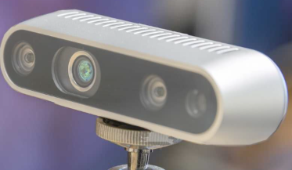
1) What is a depth camera ?:
A depth camera is a camera that captures how far every visible point in the scene is from the camera
Unlike a RGB camera that tells you what the scene looks like , a depth camera tells you how far everything is.
2)Components :
Many depth cameras include :
i)Lens
ii)Image sensor
iii)Infrared projector
iv)Infrared camera (ToF Sensor )
v)Image processor
vi)Power supply
Many depth cameras include infrared hardware because visible light isn’t always the best way to measure depth
3) how does it work ?:
There are two ways :
- Time of flight sensors (ToF):
This used infrared rays that are aimed at an object and then once it lands back on the sensor , the time taken for the infrared rays to land down is noted,
- Structured light :
So this uses an IR projector that projects on say , a flat surface. If there ‘ s an object among the flat surface , then the dots move towards or away from the flat surface
4) what information does it capture ? :
A depth camera provides:

i)Distance to each visible point
ii)A depth map
iii)Sometimes an RGB image as well (many devices include both)

5 ) what are it’s advantages ?:
i) direct depth information
ii) useful 3-d reconstruction
iii) Excellent for indoor robotics
iv)helpful for gesture navigation
v) Makes obstacle detection easier
6) What are it’s Limitations ?:
i) Can struggle outdoors in sunlight because sunlight contains a lot of infrared energy
ii) Limited sensing range
iii) Usually more expensive than a standard rgb camera
iv) Some surfaces ( very shiny or transparent ) are difficult to measure accurately

7) applications and why are they used there ? :
i) Robotics :The robots needs accurate distances to navigate and avoid obstacles
ii) Gesture recognition : the camera can detect the 3-d position of our hands and faces
iii) 3 - D scanning : A depth camera can create a 3 - D model of an object or a room by measuring distances across the scene.

#4 ) Stereo camera :
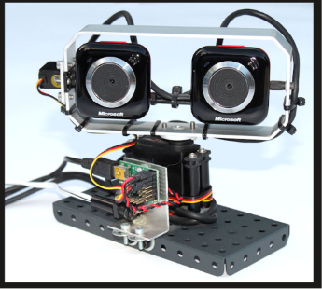
1)What is a stereo camera ?:
A stereo camera is a camera that has two cameras placed close to each other.
This is done so in order to estimate the depth of the scene by comparing those two images.
This is inspired by human binocular vision
2) How does it work ?:
Our human eyes , one on the left and one on the right capture two images that are slightly different. And based on these slight differences in terms of images , our brain estimates how far an object is away
Eg we look at a finger from first the left eye and then the right eye. In both those images that our eyes capture we notice that the finger is at a slightly different place in one image compared to the image captured by the other eye .
Like wise A stereo camera Has two separate cameras and both those cameras capture slightly different images of the same object.
Let me explain :
And the computer then compares these two images and then estimates how far away these objects are .
So It goes like this :
i) The stereo camera has two cameras as we know
ii) The stereo camera captures images using the two cameras of the object in question.
iii)Then the stereo camera estimates how far the object is from it by comparing the images and noticing the slight offset in the position of the object
This apparent shift is called disparity ( NOTE : It’s “apparent “ because the object hasn’t been physically moved in order to count it under “ actual shift )
Large disparity -> Object is close
Small disparity-> Object is far away

- Components of a stereo camera
Typically a stereo camera contains a:
- Left camera
- Right camera
- Two lenses
- Two Image sensors
- Image processor
- Synchronization circuitry ( To make sure that both cameras capture images at the same time
Unlike a RGB camera , a stereo camera is essentially two cameras calibrated and working together.
4)What Information does it capture ?:
A stereo camera captures :
i)Color ( If RGB cameras are used )
ii)Brightness
iii) The distance of the object with respect to the camera ( Depth information )

5) What are it’s Advantages ?:
i) Can estimate the distance to objects.
ii)Works without actively emitting light (It relies on the scene’s appearance )
iii) Useful for creating 3-D maps of the environment
iv) Useful for outdoor robotics where active depth sensors may not function properly
6) What are it’s limitations? :
i) requires two cameras instead of one
ii) can be more expensive
iii ) both the cameras have to be calibrated properly
iv) Can struggle where different parts of the scene look very similar.

7)What are it’s applications and why ?:
i)Autonomous vehicles :

#5) Event Camera :
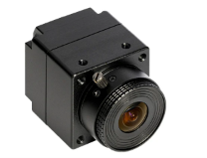

1)What is an Event Camera?:
An event camera is a camera that does not capture complete image frames at regular intervals.
Instead, it records only changes in brightness at individual pixels.
If nothing changes,
the camera produces almost no output.
2)How does it work ?
Event cameras don’t work like normal cameras
Normal cameras work like this :
They capture a video frame-by-frame
But sometimes in still places , this frame- by-frame mechanism of capturing a video doesn’t work here because a lot of storage gets eaten up

In event cameras :
They don’t have a conventional cmos sensor to process the pixels and they dont capture a video frame-by -frame, Instead each pixel can process itself and each pixel changes according to changes in brightness
For example if an event camera is recording a parked car and then the parked car leaves , then only those pixels that the parked car will see a change in brightness.
Each pixel is like it’s own processor.

3) What are the components of an event camera ?:
- An event camera consists of:
i) Lens
ii) Aperture
iii)Image sensor ( Special event sensor )
iv)Event processing circuitry
v)Processor

It doesn’t work like a normal CMOS camera
Every pixel acts almost like it’s own tiny detector
4) What information does it capture ?:
Instead of storing images , it stores events
Each image contains things like :
i) Pixel location
ii) Time of change
iii) Whether brightness increased or decreased

5) Advantages :
i) extremely fast -A normal camera might capture 30fps or 60fps
But an event camera functions in events and only those pixels that notice brightness changes change .this means very low latency
ii) No motion blur - comes in handy when you’re filming high - speed chases for films or races etc etc
iii) Low data :
If you’re watching over an empty room , then normal cameras see in terms of fps thus eating up storage
Event cameras only record change in pixels.

6) What are it’s limitations :
Everything has trade-offs.

i) Doesn't naturally produce conventional photographs.
ii) Difficult for humans to interpret directly.
iii) Many existing computer vision algorithms are designed for frame-based images, not event streams.
iv) Hardware is generally more expensive and less common than standard RGB cameras.

7) Applications and why ? :
- High-speed drones because low latency is really important when they’re moving fast and detect changes immediately to avoid obstacles
- Robotics because fast reactions are more important than capturing beautiful images
- Industrial inspections because event cameras can detect objects fast without motion blur because of the fundamental way they function in :i.e .. the pixels change according to the variations in brightness
- Gesture tracking because low latency helps in detecting hand movements fast

Types of shutters :
#1) Global shutter:
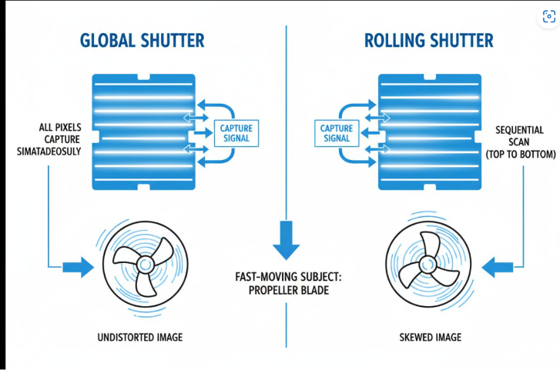
1)What is it ?:
A global shutter is a method of capturing images in which all the pixels on the image sensor are exposed to light rays at the same time
2) How does it work ? :
Imagine a classroom with 50 students and the teacher asks them to stand up ,and all of them stand up in one go .
Global shutters work similarly to the classroom analogy . All pixels capture light simultaneously
After the exposure is complete , all pixels are read out
Every pixel captures the instant at the same time .

3) 4. What information does it capture?

It captures a normal image, just like an RGB or monochrome camera.
The difference is how the image is captured, not what information it contains.

4) Advantages :
i) great for robotics
ii) Fast moving shutter helps in high-speed situations
iii) Freezes fast motion accurately
iv) Greatly reduces image distortion caused by blur motion
v) Better for industrial inspection

- What are it’s Limitations :
i) more expensive than rolling -shutters
ii) historically offered lower resolutions and high costs though this is improving with new technology

- Applications and why ?:
i) industrial inspections because production lines move fast and objects must not be distorted
ii) Robotics because robots move rapidly and accurate images help with localization and object detection( localization is the processing of helping a robot determine where it is )

#2)Rolling shutter :
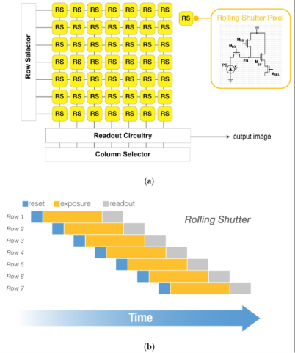
- What is a rolling shutter camera ?:
Unlike a global shutter camera where all the pixels capture light in one go , a rolling shutter camera captures pixels row-by-row
- How does it work ?:
Imagine a classroom of 50 students . This time instead of all students standing up , each student stands up row-by-row .This is very similar to how a rolling shutter camera captures images.
Instead of all pixels capturing light in one go , each rows of pixels captures light one- by - one and it starts with the first row , then the second row and so on and so on and the gap between the time at which the first row is done capturing and then the second row begins is a tiny fraction of a second in terms of magnitude

3) what information does it capture ?:
It captures the same kind of information like a rgb camera , the difference is in when the information is captured

4) Advantages ?:
i) Less expensive to manufacture than global shutters
ii) Low power consumption
iii) Widely available in smartphones ,webcams and consumer cameras
iv) Produces high-quality images for scenes with little or no motion
v) supports high-quality resolution at lower costs

5) Disadvantages? :
i) Motion distortion when the camera or object moves quickly.
ii)Fast-moving objects may appear bent, skewed, or stretched.
iii)Videos may exhibit the “jello effect “ when the camera shakes rapidly.
iv) Not ideal for high-speed robotics, industrial inspection, or machine vision applications where accurate geometry is important.

6) Applications ?:
i) Rolling shutters are used in consumer cameras , cctvs , webcams etc because they consume low energy and are affordable
In most consumer applications, scenes change relatively slowly, so rolling shutter distortions are usually minimal and not noticeable.
However, in applications involving fast-moving objects or rapidly moving cameras, such as industrial automation, autonomous robots, or drones, the distortions become more significant. In these situations, engineers often prefer global shutter cameras because they capture the entire image at the same instant.

